# OO Programming Fundamentals

# Practical Week1 - 15th September 2014

Create a **Practical Week 1** folder in your **Java folder** on your **G** drive

**G:\Java\Practical Week 1**

# Exercise 1a

Write a program that prints the message “Hello World” to the screen.

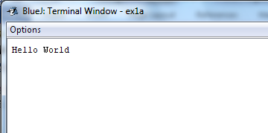

# Create project in Practical Week 1 folder as: ex1a

# Exercise 1b

Write a program that prints the message “Hello, how are you today?” to the screen.

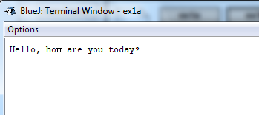

# Create project in Practical Week 1 folder as: ex1b

# Exercise 1c

Write a program that prints **your** name and address to the screen on different lines.

E.g.,

Catherine Fitzpatrick

Waterford Institute of Technology

Cork Road

Waterford

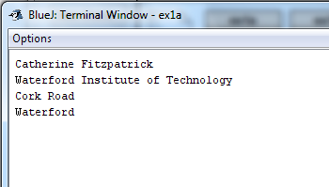

# Create project in Practical Week 1 folder as: ex1b

**NOTE\*\***

**println()** is short for print line and the effect of this statement is to start a new line after displaying whatever is in the brackets

**Completing this weeks’ Practical:**

* When you submit work, you will upload it in zip file format to Moodle.
* To create a zip file of your practical work:
  + In Windows Explorer, right click on the **Practical Week 1** folder that contains your work.
  + When the context menu appears, choose the **Send to** option, followed by the **Compressed (zipped) folder**.
  + This will create a new file called **Practical Week 1.zip** in your current folder
* Note: If you are using your own laptop, you can choose to install very good (and free) compression software called 7zip. Just search for it in Google and download it.

**\*\*\* It is this zipped file that you will upload into Moodle.\*\*\***